APPENDIX A
PHOTOGRAPHS TAKEN DURING (LEAK) JIV AT 6” OGBOINBIRI/TEBIDABA PIPELINE AT OLUGBOBORO COMMUNITY, SOUTHERN IJAW L.G.A, BAYELSA STATE ON 11TH JULY, 2024.

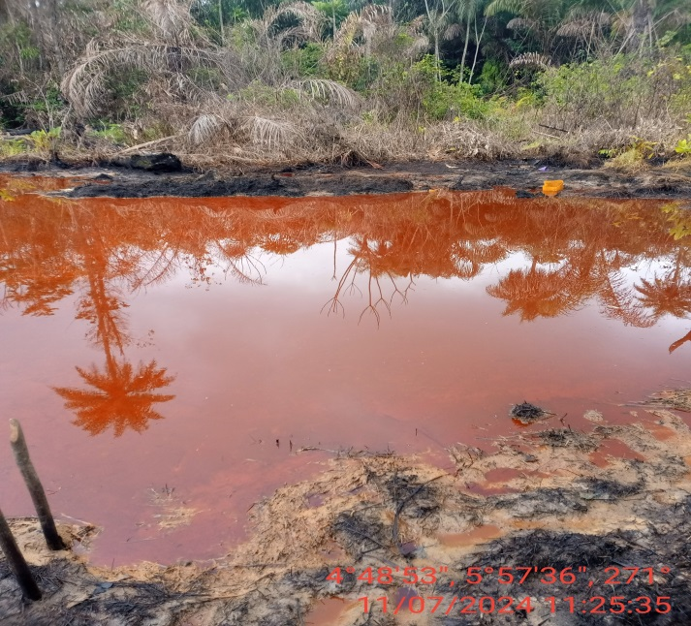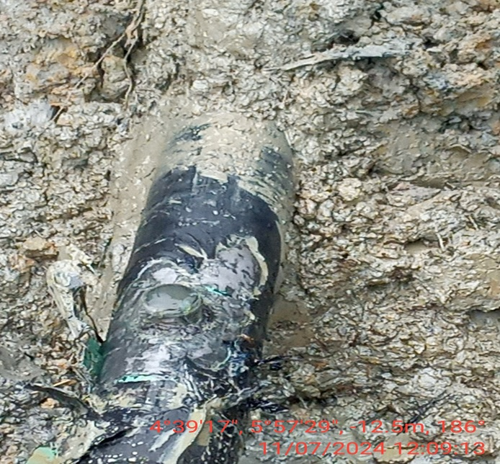
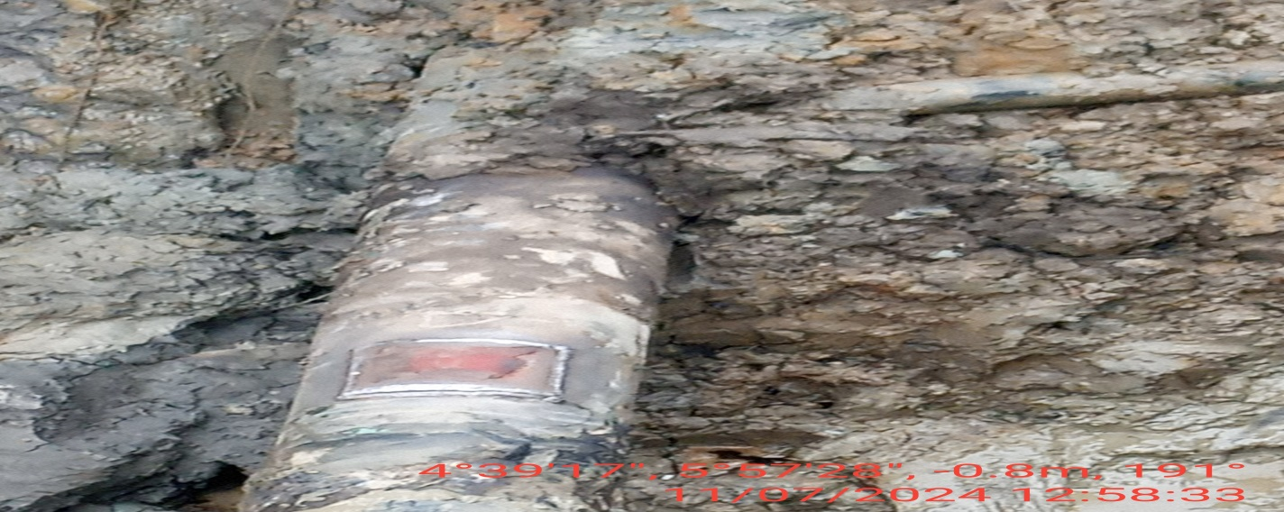
FIG. 1: (L-R) THE STATE OF THE ENVIRONMENT AS AT THE TIME OF JIV.
FIG. 2: 2” VALVE INSTALLED BY VANDALS AT 12 O’ CLOCK POSITION OF THE PIPELINE FOR POSSIBLE CONDENSATE THEFT ACTIVITY.
FIG. 3: THE INCIDENT POINT AFTER BEING PATCH WELDED.

